Title
RANT2RESOLVE

Team Name
Team Error 404

Hackathon Name
FORTEX36 HACKATHON

Submitted on
29-01-2026

Submitted by

R. NAGESH | AP23110010680
S. SOUMITH | AP23110010837
K.V. SAI TEJA | AP23110011130
N. KARTHIKEYA | AP23110010822

Github Link:

Render Link:

ABSTRACT

Universities today face significant challenges in managing student grievances and effectively communicating academic and career-related opportunities. Traditional systems rely heavily on emails, manual processes, or fragmented platforms, resulting in delayed responses, lack of transparency, and poor user experience.
This project presents a University Student Support & Public Announcement Platform, a centralized digital system designed to streamline grievance redressal and institutional communication. The platform enables students to securely raise issues, track their resolution status, and access public announcements such as internships, placement drives, scholarships, and hackathons. Administrators are provided with role-based dashboards to manage issues efficiently and ensure accountability.
Developed using modern full-stack technologies, the system emphasizes scalability, security, and usability. The platform demonstrates real-world applicability and serves as a deployable solution for academic institutions seeking digital transformation.

GitHub Repository:

PROBLEM STATEMENT

Real-Time Student Issue Reporting and Resolution Platform
Design a digital platform that allows students to report issues they face in real time and enables institutions or authorities to track, prioritize, and resolve them transparently with proper status updates and accountability.
In most universities, student grievances and academic announcements are handled through unstructured and disconnected channels such as emails, notice boards, or informal communication. These approaches suffer from several limitations:
- Lack of centralized grievance management
- Absence of issue tracking and transparency
- Delayed response times
- Scattered and inconsistent announcement dissemination
- Poor accountability among administrative bodies
Students often remain unaware of whom to contact or how to follow up on their concerns. Administrators, on the other hand, face difficulty managing a large volume of requests efficiently. There is a clear need for a single, integrated, and transparent digital platform to address these challenges.

PROPOSED SOLUTION

The proposed solution is a web-based centralized platform that bridges the communication gap between students and university administration.
Key Features:
- Secure user authentication and role-based access
- Structured grievance submission and tracking
- Administrator dashboards for issue management
- Public announcement module for opportunities
- Status updates and resolution transparency
The system allows students to privately raise concerns while enabling administrators to categorize, prioritize, and resolve issues efficiently. Public announcements are made accessible to all users, ensuring equal opportunity awareness.

TECHNOLOGY STACK

🔹 Frontend
React.js
React.js is used to build a dynamic, responsive, and interactive user interface.
- Follows a component-based architecture, making the UI modular and reusable
- Provides fast rendering using Virtual DOM
- Supports single-page application (SPA) behavior for smooth navigation
- Easily manages state and props for handling user data
- Enables responsive design for desktop and mobile devices
- Integrates well with backend APIs using Axios / Fetch
👉 Used to design:
- Login & Registration pages
- Student Dashboard
- Admin Dashboard
- Issue raising & tracking pages
- Public announcements display

🔹 Backend
Node.js
Node.js acts as the server-side runtime environment.
- Uses non-blocking, event-driven architecture
- Handles multiple users efficiently
- Ideal for real-time applications
- Improves application performance and scalability
- Allows JavaScript to be used on both frontend and backend

Express.js
Express.js is a lightweight framework built on Node.js for backend development.
- Used to create RESTful APIs
- Handles HTTP requests (GET, POST, PUT, DELETE)
- Manages routing and middleware
- Processes business logic
- Connects frontend with database
- Simplifies error handling and validation
👉 Used for:
- User authentication
- Issue submission and tracking
- Announcements management
- Role-based access control

🔹 Database
MongoDB
MongoDB is a NoSQL document-based database.
- Stores data in JSON-like format
- Flexible schema, easy to scale
- Faster for applications with frequent data changes
- Suitable for unstructured and semi-structured data
👉 Used to store:
- User profiles
- Issues and complaints
- Announcements
- Logs and system records

🔹 Security
JWT (JSON Web Token)
JWT is used for secure authentication and authorization.
- Generates a token after successful login
- Token is sent with every request for verification
- Prevents unauthorized access
- Supports role-based access (Student / Admin)
- Stateless authentication (no session storage)

Password Hashing
Used to protect user credentials.
- Passwords are never stored in plain text
- Uses hashing algorithms like bcrypt
- Enhances security against data breaches
- Even if database is compromised, passwords remain safe

🔹 Tools
Git & GitHub
- Version control system
- Tracks changes in code
- Enables team collaboration
- Maintains project history and backups

Visual Studio Code
- Lightweight and powerful code editor
- Supports JavaScript, React, Node.js, and database tools
- Provides extensions for debugging and formatting
- Improves developer productivity

🔹 Overall Architecture Benefit
- Frontend (React) handles user interaction
- Backend (Node + Express) processes logic and APIs
- Database (MongoDB / MySQL) manages data storage
- Security layers protect user data
- Tools support development and collaboration

SYSTEM ARCHITECTURE AND DESIGN

System Architecture and Design
The proposed system follows a three-tier architecture, which divides the application into independent layers. This approach improves scalability, security, maintainability, and performance, making the system suitable for real-world deployment.

🔹 Three-Tier Architecture
1. Presentation Layer (Frontend)
The Presentation Layer is responsible for user interaction and interface rendering.
- Built using React.js
- Provides a dynamic and responsive user interface
- Handles user inputs such as:
  - Login and registration
  - Raising issues
  - Viewing issue status
  - Accessing public announcements
- Communicates with the backend through secure REST APIs
- Does not contain business logic, ensuring better separation
👉 This layer focuses purely on user experience (UX).

2. Application Layer (Backend)
The Application Layer manages the core functionality of the system.
- Developed using Node.js and Express.js
- Handles:
  - Business logic
  - User authentication
  - Role-based authorization (Student / Admin)
  - Request validation and processing
- Exposes RESTful APIs for frontend communication
- Uses JWT-based authentication to secure API access
- Acts as a bridge between frontend and database
👉 This layer ensures secure, controlled, and efficient processing of user requests.

3. Data Layer (Database)
The Data Layer is responsible for persistent data storage and management.
- Uses MongoDB or MySQL
- Stores:
  - User credentials and profiles
  - Issues and complaints
  - Announcements and notices
  - System logs and records
- Ensures:
  - Data consistency
  - Reliability
  - Easy retrieval and updates
- Accessed only through the backend, enhancing security
👉 This layer guarantees data integrity and persistence.

🔹 Design Principles Followed
1. Modular Architecture
- The system is divided into independent modules
- Each module performs a specific function
- Easy to update or replace modules without affecting the entire system
- Improves code reusability and readability

2. Separation of Concerns
- UI logic, business logic, and data management are kept separate
- Frontend does not directly access the database
- Backend handles processing and validation
- Database only stores and retrieves data
👉 This results in a clean and organized codebase.

3. Secure API Communication
- APIs are protected using JWT tokens
- Sensitive data is transmitted securely
- Unauthorized access is prevented
- Role-based access ensures users see only permitted data

4. Scalability and Maintainability
- Three-tier architecture allows horizontal and vertical scaling
- New features can be added with minimal changes
- Backend and database can be upgraded independently
- Suitable for large user bases and future expansion

🔹 Advantages of the Architecture
- High flexibility for future enhancements
- Improved security through layered access
- Easy maintenance and debugging
- Supports real-world deployment
- Enhances performance and reliability
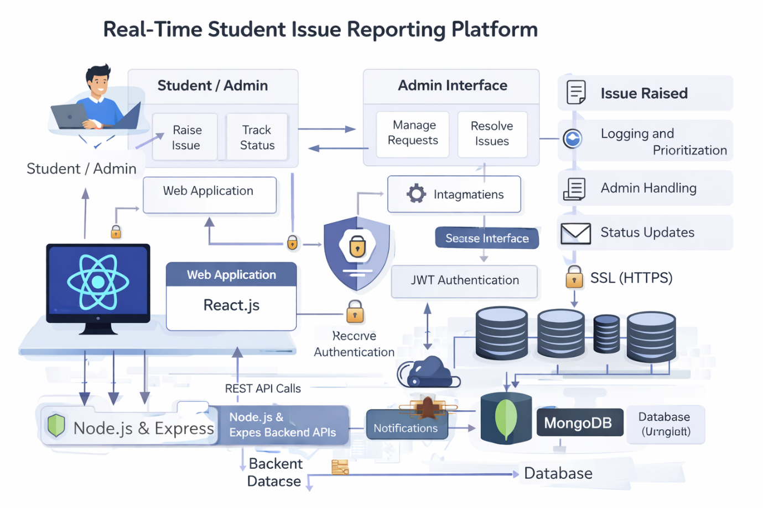

IMPLEMENTATION DETAILS

The application is implemented using RESTful APIs and a modular architecture to ensure simplicity, scalability, and maintainability.
Core Modules
- Authentication Module – Handles user login and registration with secure password hashing and JWT generation.
- Student Dashboard – Allows students to raise issues, track their status, and view announcements.
- Admin Dashboard – Enables admins to manage issues and publish announcements.
- Issue Management System – Supports issue submission, tracking, and resolution.
- Announcement Management System – Manages public notices such as placements and scholarships.
Design Approach
- Backend follows MVC-style separation (routes, controllers, models) for clean logic handling.
- Frontend uses reusable React components for consistency and faster development.
- JWT-based middleware secures protected routes and enforces role-based access.
This implementation ensures efficient development, secure access, and easy future enhancements.

RESULTS AND DEMONSTRATION

The developed platform successfully demonstrates the following outcomes:
- End-to-end grievance submission and resolution
- Real-time issue status tracking
- Secure, role-based dashboards for students and admins
- Centralized announcement broadcasting to all users
All core functionalities were implemented, tested, and validated within the project timeline, confirming the feasibility, reliability, and effectiveness of the proposed solution.

Github Link:

Render Link:

CHALLENGES FACED

During development, the team encountered several challenges:
- Limited development time during the hackathon required fast decision-making and prioritization of core features.
- Frontend and backend integration needed careful API coordination and testing.
- Secure authentication and authorization were challenging to implement correctly using JWT and role-based access.
- Database schema optimization was required to ensure efficient data storage and retrieval.
These challenges were effectively addressed through iterative development, continuous testing, and collaborative problem-solving, leading to a stable and functional system.

FUTURE SCOPE

- Limited development time during the hackathon
- Frontend and backend integration complexity
- Implementing secure authentication and authorization
- Optimizing database schema for performance
- Ensuring smooth API communication
- Managing testing within time constraints
Resolution:
- Addressed through iterative development, continuous testing, and collaborative problem-solving.

CONCLUSION

The University Student Support & Public Announcement Platform delivers a robust, scalable, and transparent digital solution to address key operational challenges commonly faced by academic institutions. By centralizing grievance management and public opportunity dissemination within a single platform, the system significantly enhances communication efficiency between students and administration while ensuring accountability and timely resolution of issues.
The implementation of role-based dashboards, secure authentication, and a modular three-tier architecture ensures reliability, data security, and ease of maintenance. Real-time issue tracking and centralized announcements contribute to improved student engagement and satisfaction, while administrators benefit from better visibility and streamlined management processes.
Overall, the project successfully demonstrates technical feasibility, practical usability, and scalability, making it well-suited for real-world deployment across universities and colleges. With further enhancements such as analytics, notifications, and mobile integration, the platform shows strong potential for institution-wide adoption and future commercialization.

REFERENCES
- React.js Official Documentation – https://react.dev
- Node.js Official Documentation – https://nodejs.org
- Express.js Documentation – https://expressjs.com
- MongoDB Official Documentation – https://www.mongodb.com/docs
- MySQL Official Documentation – https://dev.mysql.com/doc
- JSON Web Token (JWT) Documentation – https://jwt.io
- bcrypt Documentation – https://www.npmjs.com/package/bcrypt
- RESTful API Design Guidelines – https://restfulapi.net
- Git Official Documentation – https://git-scm.com/doc
- GitHub Documentation – https://docs.github.com
- MDN Web Docs (JavaScript & Web Standards) – https://developer.mozilla.org
- Visual Studio Code Documentation – https://code.visualstudio.com/docs

